Phone: + 44 20 8959 8996 Mail: EvaMorrisLondon@aol.com
Eva Szita-Morris (PhD econ, PCC, CPCC, ORSCC)
Background  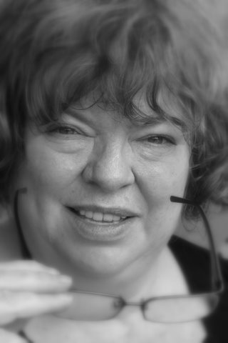 | Eva is an experienced leadership and business coach and teacher with a multinational client portfolio across Europe. She is a supervisor for the two leading American Coaching Schools. A British National since 1990, Eva began her career as a doctorate level economist in Hungary.  Achievements includes in 1999-2012  - Leading one year Leadership Course and one to one coaching for 7 top executives in very large international (American, French, German)company based in Europe (2008-2009)  - Over 4000 hrs of coaching delivered to international clientele at many levels. One of best trained coach in the UK and internationally  - Coaching course at MIP Milano, MBA course (2010)  - Team coaching, evaluations. E.g. Norway: Det Norske Veritas AS.  - One to One Supervision for top professional training schools –see below- over 2500 hours for coaches to be certified by ICF all over the world (E.g. Japan, France, UK, USA, South Africa – over 20 nationalities). Supervising one to one coaches and relationship and team coaches.  - Relationship and team coaching in various companies  - Eva has been successfully practicing since 2000, working only by recommendations!  - Coaching in organisations: top executives and leaders, teams, boards, plus divisional, functional, and departmental managers.  - Designed and delivered the risk management, leadership & coaching workshops in the field.  - WIN Conference (International Business Conference) – 2002, 2003, 2004, 2005 ,2006, 2007, 2010,2011 – Coaching Labs & Presenting various Leadership and Risk workshops  - Delivered cutting edge diagnostic assessment to measure productivity and positivity in teams  Teaching circles:  - Faculty member of the Coaches Training Institute. Supervisor for CTI’s professional certification programme.  - Faculty member Centre for Right Relationship (CRR). Relationship coaching, systems, and organisational coaching. Supervisor for CRR’s coach certification programme.  - Designed and delivered the risk management, leadership & coaching courses  Previously  - Organising volunteering. Had a part time role in building up the volunteer group of mostly professional volunteers in the Medical Foundation for the Care of Victims of Torture in London between 1998-2009 from 70 to 250, introducing all the norms, good practice regulations, and systems to deal with volunteers. Developing Staff handbooks.  - Senior Risk Consultant to Hargreaves Risk Management. Introduced leading edge British/American business methods internationally (Risk Management) 1996-1999  - International Know How Transfer. Spreading practical business knowledge as Operations Director of a Volunteer Venture for Eastern European countries with the British Government’s Know-How Fund (e.g. Mortgage banking) 1990- 1996  - Investment consultant to International Investment Funds: John Govett Fund and IMI Securities 1990-1995  - Developing business opportunities with a Hungarian International Law Firm and Patent Agency 1987  - Visiting researcher/lecturer: France: banks, major businesses. The Netherlands: John F. Kennedy Institute. University of Columbia, University of Berkeley (USA) 1982-86  - USA: Scholarship research in declining industries: Boston College, University of Columbia, University of Berkeley and Research Institutes in Philadelphia and Washington. 1986  Author: 25 articles, and a book (in economics)
Languages | Fluent English, French, and Hungarian.(some Italian and Russian)
Education and Training | - Doctorate degree Summa Cum Laude in Economics, Budapest 1977  - Certified Professional Coactive Coach accredited by the International Coach Federation (CPCC), and PCC (Professional Certified Coach) (1999-2010)  - Clean Language 2005  - Coactive Space (USA): ten-month intensive leadership program graduate 2006  - Action Learning 2006  - Certified in Systemic Team Assessment 2006  - Leadership Circle: trained as Action Learning Set facilitator 2007  - Certified in Organization and Relationship Systems Coaching 2008  - Leadership circle -2010  - Alchemy 3™ The Art and Magic of Creating from Relationship 2008
Employment Timeline | 1977- 1985 Research fellow. Institute of World Economics. Hungarian Academy of Science  1985-1987 Hungarian International Law Firm and Patent Agency 1987  1989- 1996 British Know How Fund Project  1996- 1999 Hargreaves Risk Management  1999- 2010 Medical Foundation for the Caring for Victims of Torture (part time)  1999 – Self-employed, Associate with leading Coaching Institutions, member of Coaching Faculties, executive, private and leadership coach
Experience | - Experienced telephone and face-to-face coaching, locally and overseas  - Team facilitator including boards, and team building  - Leadership and Management training  - Experiential workshops

